**DLD Assignment-3**

1. **If the waveforms in Fig-1 are applied to an active-Low S-R latch, draw the resulting Q output waveform in relation to the inputs. Assume that Q starts Low.**

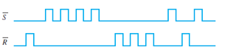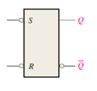

Fig-1

1. **Solve problem -1 for the input waveform in Fig-2 applied to an active –High S-R latch.**

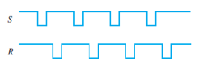

Fig-2

1. **Solve problem -1 for the input waveform in Fig-3.**

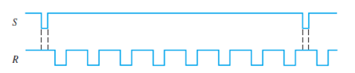

Fig-3

1. **For a gated S-R latch, determine the Q and Q’ output for the inputs in Fig-4. Show them in proper relation to the enabled input. Assume that A starts LOW.**

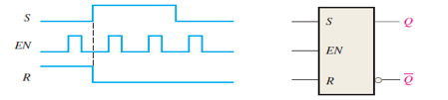

Fig-4

1. **Determine the output of the gated D latch for the inputs in Fig-5 and Fig-6.**

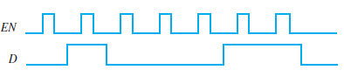

Fig-5

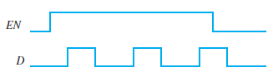

Fig-6

1. **The Q output of an edge-triggered D flip-flop is shown in relation to the clock signal in Fig-7. Determine the input waveform on the D input that is required to produce this output if the flip-flop is a positive edge-triggered type.**

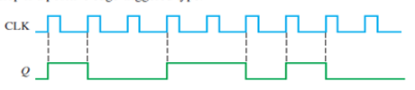

Fig-7

1. **Draw the Q output relative to the clock for D flip-flop with the inputs shown in Fig-8. Assume positive edge-triggered and Q initially LOW.**

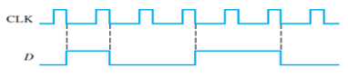

Fig-8

1. **Solve the problem-7 for input in Fig-9 and Fig -10**

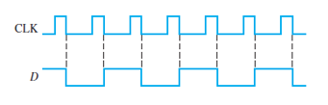

Fig-9

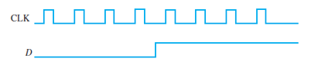

Fig-10

1. **Determine the Q waveforms relative to the clock if the signal shown in Fig -11 are applied to the input of the J-K flip-flop. Assume that Q initially LOW.**

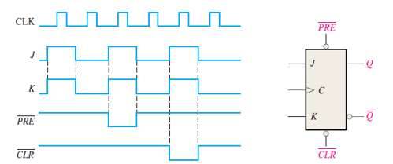

Fig-11

1. **For negative edge-triggered J-K flip-flop with the input in Fig-12, develop the Q output waveform relative to the clock. Assume that Q is initially LOW.**

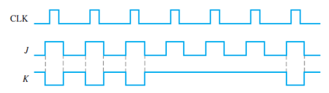

Fig-12

1. **For the circuit in Figure -14, complete the timing diagram in Fig-13 by showing the Q output (which is initially LOW). Assume PRE and CLR remain HIGH.**

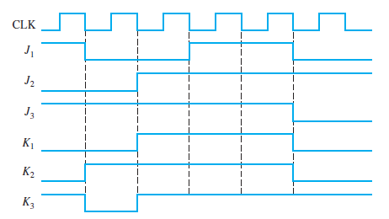 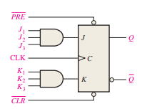

Fig-13 Fig-14

1. **A D flip-flop is connected as shown in Fig-15. Determine the Q output in relation to the clock. What specific function does this device perform?**

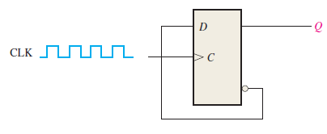

Fig-15

1. **For the circuit in Fig-16, develop a timing diagram for eight clock pulses, showing the QA and QB outputs in relation to the clock.**

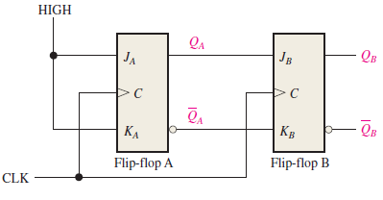

Fig-16